CS 3450 – Principles and Patterns of Software Design

Homework

Homework assignments 1-5 follow; see syllabus for due dates for each:

- (No Chapter):
  - Part 1: Read (or at least skim) “Software Patterns”, available from Canvas Readings or from the following url: http://sites.google.com/a/gertrudandcope.com/info/Publications/Patterns/WhitePaper
  - Part 2: Write your own pattern, following the pattern template given in the slides (called the Coplien form.) The pattern should be from 2 to 4 pages long. It can be about anything you have found a solution to; it doesn’t have to be about software. Submit it online and bring ten paper copies to class.
- Chapter 1: do the Design Puzzle on page 25 of the textbook. Draw the resulting class diagrams in standard UML (NOT like the book uses). Implement the code in your language of choice. Use simple print statements in the methods to trace execution.
- Chapter 2: Suppose you have n subjects and m observers, and each observer can observe multiple subjects. In other words, there is a many-to-many relationship between subjects and observers. Discuss a variation of the Observer that solves this problem. Discuss its positive and negative consequences. Illustrate your discussion with appropriate UML diagrams.
- Chapters 4-5: Simulate a program that draws Widgets and prints Documents. This program uses low-resolution drivers for printing and displaying or high-resolution drivers, depending on the platform (both are low or high together – they never mix). Therefore, there needs to be a way to configure instances of Widget and Document with the correct driver at runtime. Only one copy of each of the four drivers (LowResDisplayDriver, HighResDisplayDriver, LowResPrintDriver, HighResPrintDriver) is to exist at any one time. For our purposes, Widget has a draw( ) method that just says a Widget is being drawn with either a LowResDisplayDriver or a HighResDisplayDriver. In a similar fashion, Document has a print( ) method. A main driver program might read its resolution setting from a file and draw a Widget and print a Document, resulting in:

Drawing a Widget using a LowResDisplayDriver
Printing a Document using a LowResPrintDriver

or, if the platform supported high resolution:

Drawing a Widget using a HighResDisplayDriver
Printing a Document using a HighResPrintDriver

As mentioned earlier, assume that a platform supports only high resolution for both printing and displaying, or low resolution for both. (This is pretty reasonable, actually; the scenario here is to support outdated workstations vs. up-to-date ones. And of course, the goal is also to use patterns from Chapters 4 and 5 :-). Prepare UML diagrams that document all of your classes and code and test an implementation of your design.

Note: you should be using an abstract factory in this homework.

Note: Think about your inheritance! Some students get in trouble because they have inheritance hierarchies that don’t make sense!

… homework 5 is on the next page …
- Chapter 7:
  - Suppose you have a Shape hierarchy as follows:

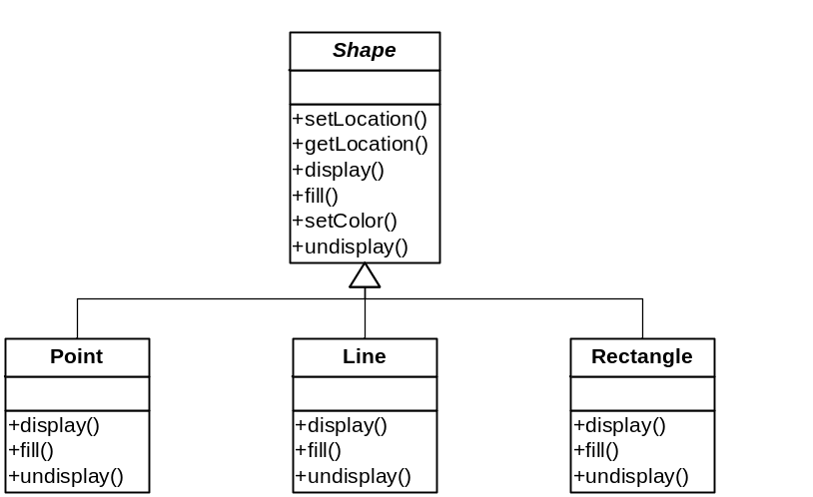

Now you want to add a Circle class, but you hear that someone else has already created one, named XXCircle, and you just want to reuse it. Its interface is slightly different though:

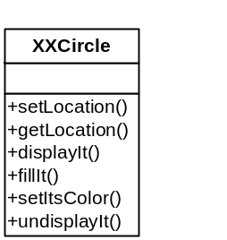

Draw a UML diagram that adapts this class to your hierarchy. Write skeleton code that just uses print statements for all the methods, and write a test driver that creates a sequence of Shapes and displays all of the shapes it contains, verifying that your Circle class nicely coexists with the other types of Shape.
  - A web application uses a database to get Employee data. The application could use the database API directly, but this would result in a number of low-level SQL calls scattered throughout the code (setting the connection, building queries, extracting results, building Employee objects, etc.). Explain how you can design the application so that it is not directly dependent on the database used, and so getting and setting employee data won’t be such a pain.

